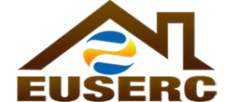
ELECTRIC UTILITY SERVICE EQUIPMENT
REQUIREMENTS COMMITTEE

MEETING AGENDA
Member Utilities
Operating in the
Following States:
ALASKA
ARIZONA
CALIFORNIA
COLORADO
HAWAII
IDAHO
MONTANA
NEVADA
NEW MEXICO
NORTH DAKOTA
OREGON
UTAH
WASHINGTON
WYOMING
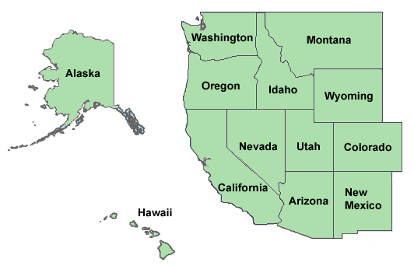
Non-Utility
Members:
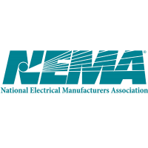California Public
Utilities Commission
Underwriters
Laboratories, LLC
California ISO

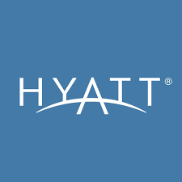
Meeting Date: Tuesday– August 1, 2017
Meeting Type: Executive Board Meeting
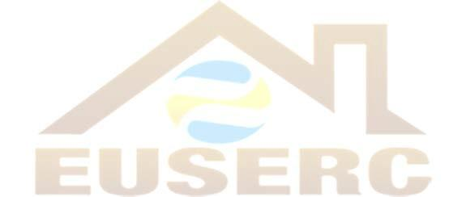
Time: 1:00pm – 4:00pm
Location: Consult hotel reader board
This Meeting is only for the Executive Board and Sub-committee Chairpersons
Item 1: Approval of Minutes
Item 2: Treasurers Report
Item 3: Correspondence
Item 4: Old Business
Item 5: New Business
Item 6: Vice Chair Report
Item 7: Sub-Committee Report
- Section 100/200 Sub-Committee Report
- Section 300 Sub-Committee Report
- Section 400 Sub-Committee Report
- Section 500 Sub-Committee Report
- Section G Sub-Committee Report

Item 8: Forms Committee Report

Item 9: Member-At- Large Report

Item10: Materials Committee Report

Item 11: Adjourn Meeting

ELECTRIC UTILITY SERVICE EQUIPMENT
REQUIREMENTS COMMITTEE
Member Utilities
Operating in the
Following States:
ALASKA
ARIZONA
CALIFORNIA
COLORADO
HAWAII
IDAHO
MONTANA
NEVADA
NEW MEXICO
NORTH DAKOTA
OREGON
UTAH
WASHINGTON
WYOMING
Non-Utility
Members:
California Public
Utilities Commission
Underwriters
Laboratories, LLC
California ISO

MEETING AGENDA
Meeting Date: Wednesday – August 2, 2017
Meeting Type: General Membership Meeting
Time: 8:00am – 4:00pm
Location: Consult the Hotel reader board
This meeting is open to all members
8:00am – 12:00pm
Item 1: Flag Salute
Item 2: Self Introductions
Item 3: Welcome by Riverside Public Utilities
Item 4: Reading and approval of November 2016 meeting minutes
Item 5: Treasurers Report by Tiffany Maycumber
Item 6: Executive Chair Report by Gilbert Aceves
Item 7: Correspondence Report
Item 8: Old Business
Item 9: New Business
Item 10: Vice-Chair Report by Mohammed Khan
Item 11: Materials Chair Report by Art Casillas
Item 12: Forms Committee Report by Greg Fellin
Item 13: Sub-Committee Reports
- Section 100/200 Report by Eric Cardella
- Section 300 Report by Greg Yates
- Section 400 Report by Steve Abeyta
- Section 500 Report by Kevin Bausch
- Section G Report by Craig Greer
BREAK FOR LUNCH
Item 14: Other reports – NEMA, UL, and NEC.
Presentation by UL representative. TBD
Adjourn Recorded Meeting
Item 15: Open Forum
Item 16: Sub-Committee Workshops

ELECTRIC UTILITY SERVICE EQUIPMENT
REQUIREMENTS COMMITTEE
Member Utilities
Operating in the
Following States:
ALASKA
ARIZONA
CALIFORNIA
COLORADO
HAWAII
IDAHO
MONTANA
NEVADA
NEW MEXICO
NORTH DAKOTA
OREGON
UTAH
WASHINGTON
WYOMING
Non-Utility
Members:
California Public
Utilities Commission
Underwriters
Laboratories, LLC
California ISO

MEETING AGENDA

Meeting Date: Thursday – August 3, 2017
Meeting Type: General Membership
Time: 8:00am – 12:00pm
Location: Consult the Hotel reader board
This meeting is open to all members
8:00am – 10:00am
Item 1: Sub-Committee Reports
- Section 100/200 Report by Eric Cardella
- Section 300 Report by Greg Yates
- Section 400 Report by Steve Abeyta
- Section 500 Report by Kevin Bausch
- Section G Report by Craig Greer

Item 2: Old Business
Item 3: New Business
Item 4: Section Chairpersons Reports

- Vice-Chairperson – Mohammed Khan
- Form Chairperson – Greg Fellin
- Materials Chairperson – Art Casillas
- Member-at-Large – Mike O’Meara
- Treasurer- Tiffany Maycumber

10:00am – 12:00pm

Item 5: Training Topic: “Energy Storage” presented by Mike Stone
Adjourn Recorded Meeting
Item 6: Open Forum

Presentation Notes:

If you have any questions or presentation topic ideas, please call Gilbert
Aceves, Chairperson, at 1-909-329-9445

