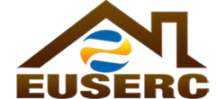
ELECTRIC UTILITY SERVICE EQUIPMENT
Member Utilities
Operating in the
Following States:
ALASKA
ARIZONA
CALIFORNIA
COLORADO
HAWAII
IDAHO
MONTANA
NEVADA
NEW MEXICO
NORTH DAKOTA
OREGON
UTAH
WASHINGTON
WYOMING
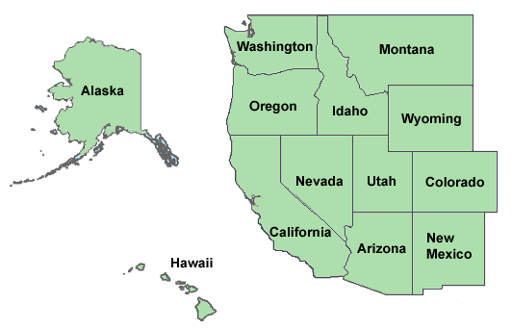
Non-Utility
Members:
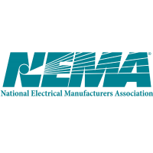California Public
Utilities Commission
Underwriters
Laboratories, LLC
California ISO

REQUIREMENTS COMMITTEE

EUSERC MEETING ANNOUNCEMENT
Meeting Dates: January 31 - February 2, 2017
EUSERC Contacts: Gilbert Aceves 1-909-329-9445
Tiffany Maycumber 1-619-540-1391
Hosted By: San Diego Gas & Electric
SDG&E Contact: Tiffany Maycumber 1-619-540-1391
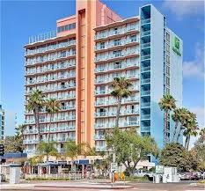
Location:
1355 North Harbor Drive
San Diego, CA 92101
1-619-232-3861
Hotel Accommodations:
Room group rates are $219.00 (01/31/2017 – 02/02/2017) per night plus
State tax of 10.5%, user fee of 2.0% and misc. tax of 0.25%. Parking
fees are $29.00 per day and valet parking for $40.00 per day.

Reservations can be made on line, https://resweb.passkey.com/go/EUSERC2017
or by calling the hotel directly, @ 1-619-232-3861 and mention “EUSERC “EUSERC group meeting”
Transportation:
Airport transportation by shuttle is complimentary. Please call the hotel
to make arrangements at 1-619-232-3861.
Meeting Agendas:
Tuesday (1/31/2017) – BOD meeting 12:00pm – 4:00pm
Wednesday (2/1/2017) – General Membership meeting 8:00am – 5:00pm
Thursday (2/2/2017) – General membership meeting 8:00am – 12:00pm
This meeting will include two hours of training topic (TBA).
** ALL MEETINGS WILL BE HELD AT THE HOTEL*

