ELECTRIC UTILITY SERVICE EQUIPMENT
REQUIREMENTS COMMITTEE
Member Utilities
Operating in the
Following States:
ALASKA
ARIZONA
CALIFORNIA
COLORADO
HAWAII
IDAHO
MONTANA
NEVADA
NEW MEXICO
NORTH DAKOTA
OREGON
UTAH
WASHINGTON
WYOMING
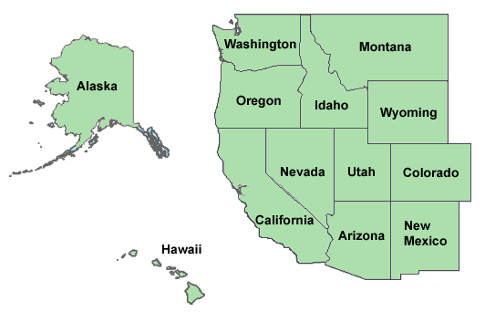
Non-Utility
Members:
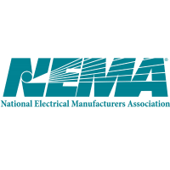California Public
Utilities Commission
Underwriters
Laboratories, LLC
California ISO

EUSERC MEETING ANNOUNCEMENT

Meeting Dates: August 1-3 2017
EUSERC Contacts: Gilbert Aceves 1-909-329-9445
Tiffany Maycumber 1-619-540-1391
Hosted By: Riverside Public Utilities

City of Riverside Contact: Greg Yates, 1-951-288-8596
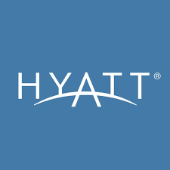
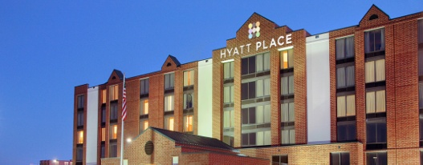
Location:
3500 Market Street
Riverside, California 92501
1-951-321-3500

Hotel Accommodations:
Please contact hotel for room rates. Make reservations on-line or by calling the hotel at 1-951-321-3500. The hotel offers free Wi-Fi and has paid parking.
Transportation:
There is no hotel shuttle service available from/to Ontario Airport.
.
Meeting Agendas:
Tuesday (8/01/2017) – BOD meeting 1:00pm – 4:00pm
Wednesday (8/02/2017) – General Membership meeting 8:00am – 4:00pm
Thursday (8/03/2017) – General membership meeting 8:00am – 12:00pm
This meeting will include a training class on: “Energy Storage” presented by N.E.M.A representative, Mike Stone

** ALL MEETINGS WILL BE HELD AT THE HOTEL*

