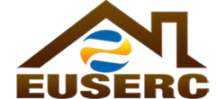
ELECTRIC UTILITY SERVICE EQUIPMENT
Member Utilities
Operating in the
Following States:
ALASKA
ARIZONA
CALIFORNIA
COLORADO
HAWAII
IDAHO
MONTANA
NEVADA
NEW MEXICO
NORTH DAKOTA
OREGON
UTAH
WASHINGTON
WYOMING
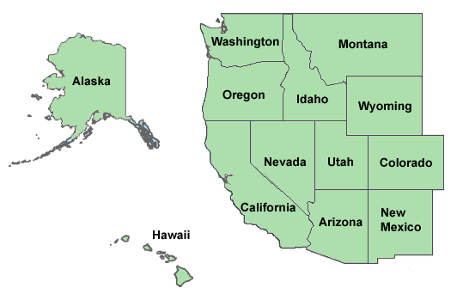
Non-Utility
Members:
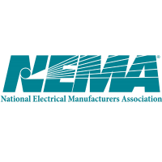California Public
Utilities Commission
Underwriters
Laboratories, LLC
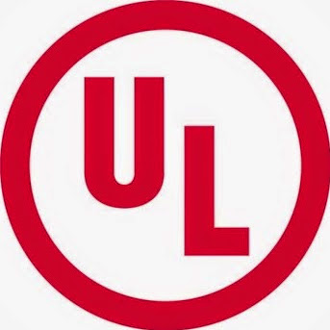
California ISO

REQUIREMENTS COMMITTEE

1355 North Harbor Drive, San Diego, CA 92101
1-619-232-3861
MEETING AGENDA
Meeting Date: Thursday – February 2, 2017
Meeting Type: General Membership Meeting
Time: 8:00am – 12:00pm
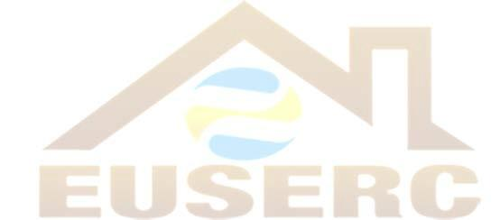
Location: Consult the Hotel reader board
This meeting is open to all members
8:00am – 10:00am
Item 1: Sub-Committee Reports
- Section 100/200 Report by Eric Cardella
- Section 300 Report by Greg Yates
- Section 400 Report by Steve Abeyta
- Section 500 Report by Kevin Bausch
- Section G Report by Craig Greer

Item 2: Old Business
Item 3: New Business
Item 4: Section Chairpersons Reports

- Vice-Chairperson – Mohammed Khan
- Form Chairperson – Greg Fellin
- Materials Chairperson – Art Casillas
- Member-at-Large – Mike O’Meara
- Treasurer- Tiffany Maycumber

10:00am – 12:00pm

Item 5: Training and Presenter TBA
Adjourn Recorded Meeting
Item 6: Open Forum

Presentation Notes:

If you have any questions or presentation topic ideas, please call Gilbert
Aceves, Chairperson, at 1-909-329-9445

